Football CV – Farid Nejat Pashaki

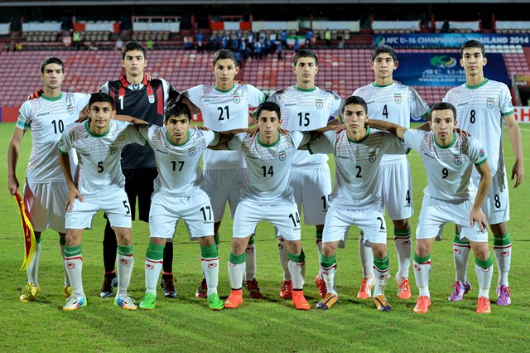

Name: Farid Nejat Pashaki Contact Information:
DoB: 6 January 1998 Email: farid.nejat.p@gmail.com
Height: 1.85 Meter Phone: +98 9309577361
Weight: 80 Kg
Birthplace: Isfahan, Iran
Position: Goalkeeper

Personal Summary

Since I was a little boy, I dream about goalkeeping on a professional football club. So I have started my career in Sepahan FC, one of the most decorated football clubs in the country. Soon I became the first goalkeeper of my team and I have been invited to join national team, in order to participate in Inter Campus tournament 2009 hold by Inter FC in Italy. Our team stood on first place alongside Cameron. That was the start and I grow more. Since then, I have pursued my career on top level in my club and my country’s national club. And I have been awarded as the best goal keeper of the Azerbaijan tournament 2014. My ambition to learn more and be more creative and steadier on the pitch brought me here, as who I am now, and I want to continue to learn and achieve more on your club. The future is always bright and I’m looking forward to make history with your club.

Playing Experience

YEAR CATEGORY CLUB COACH (Reference)

2008-2009 U12 Sepahan Asghar Mehdipour
2009-2010 U13 Sepahan Javanmardi
2010-2011 U14 Sepahan Saeid Jahangiri
2011-2012 U15 Sepahan Saeid Jahangiri
2012-2013 U16 Isfahan Selected Team Masoud Shirvani
2012-2013 U16 Sepahan Babak Yavari
2013-2014 U17 Sepahan Saeid Jahangiri
2014-2015 U18 Sepahan Saeid Jahangiri
2015-2016 U19 Sepahan Saeid Orangi
2016-2017 U21 Zob Ahan Hasan Hajrasouliha
2017-2018 U21 Zob Ahan Hasan Steki

National Achievements

- 1st Place, U12 Student Cup - 2008-2009
- 1st Place, U12 National Competition – Sepahan FC – 2008-2009
- 1st Place, U16 National Competition – Sepahan FC - 2012-2013
- 1st Place, U17 National Competition – Sepahan FC – 2013-2014
- 2 Place Student Cup, Isfahan Selected team, 2012 - 2013
- 1st place, U18 National Competition – Sepahan FC – 2016-2017
- 1st place, U21 National Competition – Zob Ahan FC – 2017-2018
- 2 Years in Sepahan FC Adult team 2014-2015 and 2015-2016
- 1 years in Zobahan FC adult team 2019-2020

International Achievements

- 1st Place, U12 national team with Cameron on Inter Campus tournament. 2009, hold by Inter FC, Italy.
- Champions, U15 National team, Pakistan 2012, Asian Games Qualification
- 3rd Place, U16 national team, Italy 2013, Franco Gallini memiorial.
- 2nd Place, U16 National team, Kazakhstan 2013, presidential cup
- 2nd place, U16 national team, Indonesia – Malaysia 2014, Frenzcup
- Champions, U16 national team, Azerbaijan 2014, Azerbaijan cup
- Attendance in Tournaments of Japan, July 2014
- Attendance in Asian Cup in Thailand, Aug 2014

National Developments

- Invitation to Camp of National Team, 2009 - 2015
- On the starting XI of National Team ,2009 – 2014

Personal Achievement

- Best Goalkeeper, Azerbaijan 2014, Azerbaijan cup

Video Footage

https://youtu.be/dR8qqRUcQnw

https://en.wikipedia.org/wiki/2013_Kazakhstan_President_Cup_(football)

http://www.the-afc.com/news/afcsection/afc-u-16-cship-qf-iran-0-0-dpr-korea-2-4-pens-20547

http://www.the-afc.com/news/afcsection/afc-u-16-cship-iran-3-2-qatar-8482

http://www.the-afc.com/news/afcsection/afc-u-16-cship-saudi-arabia-1-2-iran-8504

https://youtu.be/W4us-fnB-s0

